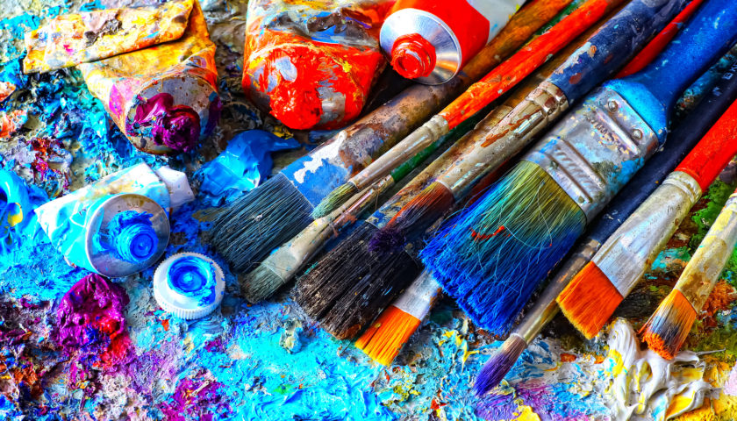

VISUAL ARTS at A.I.S. with Mrs. Groenstein
hgroenstein@crec.org * www.wildcatsarts.weebly.com * www.hlgroen.com

BIG IDEA: Within an inclusive, constructive, and communal learning environment and through the establishment of artmaking; students will celebrate their creative spirit, foster self, expression, inspire pride and achievement. Students will be encouraged to be open-minded and culturally responsive while developing a life-long appreciation for art.

KEY KNOWLEDGE: Within the Visual Arts program at A.I.S. students will assemble works of art utilizing artistic tools and mediums. Students will learn to foster a more whole-brained scholastic experience, creative techniques and demonstrate problem solving skills as they study foundations and the elements and principles of design. Students will discover personal meaning while experimenting with art and integrating multiple forms of disciplines. Students begin to implement principles more independently and in greater depth as they move toward developing a personal artistic voice, taking responsibility for creating and interpreting works of art.
ESSENTIAL QUESTION:
Why might learning about art impact not only how we see the world but how we see ourselves; past, present, and future?

HOW TO SUCCEED IN VISUAL ARTS:
Aim for the best and try to do the right thing; be a positive leader and stay on task.
Respect yourself, your classmates, your teachers, your supplies, and the classroom.
Trust in yourself and your ability to learn. Don’t be afraid to fail and work from your mistakes.
Inside voices: focus on the work and not the conversation.
Stay safe and give each other space. Hands and feet to yourselves.
Turn mistakes into masterpieces.

KEEP AN OPEN MIND AND HAVE A POSITIVE ATTITUDE!
STUDENT GRADING POLICY:
40% Overall Performance: Final assignments/projects quality and completion
30% Studio: productivity and participation
15% Written/verbal assessments: Content knowledge
15% Behavior - Students must follow school wide and art expectations to succeed.

WHAT IS ART?
Art is a way of seeing. The Visual Arts are an integral part of the human experience. They are the visual expression of the emotional, spiritual, cultural, social, and intellectual facets of humanity.
ENDURING UNDERSTANDINGS FOR THE VISUAL ARTS
- The process of making art leads to a deeper understanding of ourselves and others.
- Creativity and imagination are enhanced through the study and creation of art.
- The creation of art fosters self-discipline and perseverance.
- Artists communicate ideas and emotion in their work.
- Artists develop their own unique style.
- People interpret art in different ways.
- Art portrays and transmits culture.
- The arts are essential to the human experience.

ELEMENTS OF ART
- Line is a path through space that can convey emotions
- Shape is two-dimensional and can be generalized into organic and geometric categories.
- Form is a three-dimensional shape, either real or an illusion.
- Values are the lights and darks that create contrast in composition.
- Accurate representation of texture in art helps create visual interest.
- Knowledge of color can help artists communicate their ideas more effectively.
- The use of space in design helps define perspective and depth.

PRINCIPLES OF DESIGN
- Balance creates a sense of stability, where no one part overpowers another.
- Emphasis attracts and holds the viewer’s attention.
- Movement is used by artists to guide the viewers’ eye through a composition.
- Unity is the effective blending of the elements to create a feeling of completeness.
- The use of contrast makes a work of art more visually interesting.
- Harmony is the repetition of an element to create unity.

