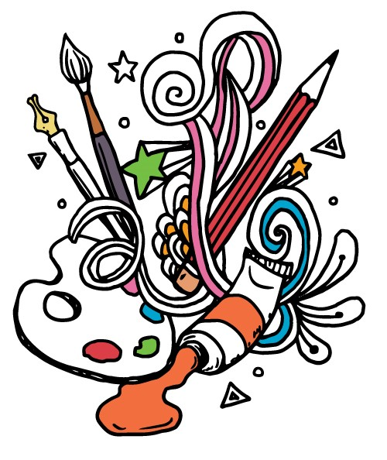
Grade: Class: Name:
Visual Art Project Self Reflection:

What did you decide to create and why?

What were the steps in creating your artwork?

What did you find enjoyable about creating your artwork?

What was successful? What wasn’t?

Did you discover anything about yourself or the process of making art? Ex: Research, historical facts, self-discovery.

Questions you might still have?

